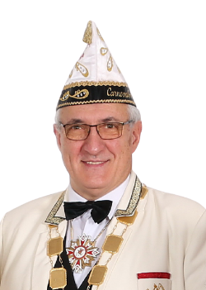
Greetingsfrom the Carneval CommitteeWesel e.V.
Carnival in Felixstowe meets carnivalists from Wesel.
Dear Friends at Felixstowe,
Time goes quickly passing by.
The time has come to send our friends in Felixstowe
greetings from Wesel.
It's been a long time since we carnivalists were able to visit Felixstowe for the Carnival. Brexit brought its share of problems. Corona prevented us from seeing and meeting each other. At the moment it is not easy to think of celebrations in Europe. Thinking of friends always works.
We had to cancel all carnival celebrations in Wesel. Events were also banned in the carnival strongholds of Cologne and Düsseldorf. Only a few small events remained possible.
After a long time, it snowed again in Wesel in January. With our prince and princess we took advantage of the short winter time in the snow and were able to take beautiful photos. See photo in the snow.
Not being allowed to celebrate Carnival two years in a row, not being allowed to visit our friends in Felixstowe two years in a row is really enough. It's time to break the shackles that Corona has put on us.
On 19 November 2022, we will celebrate our Grand Proclamation in a new look and setting. A big event is to take place in our event hall. The planning is underway. Artists are booked. The concept is ready. We have switched to Modus Karneval and are now showing the virus where to go.
In July 2022, Felixstowe will once again celebrate the Carnival. A special date this year. The FELIXSTOWE ANNIVERSARY CARNIVAL WEEKEND is a special event. Some carnivalists from Wesel take advantage of this special event and visit Felixstowe together with our Prince and Princess to finally celebrate with friends in Felixstowe again.
Prince André I and his Princess Susanne II. Are already in the starting blocks and eagerly awaiting the visit.
Julie Bellamy, Chairman of the Felixstowe Carnival Association, said: “We are pleased to bring the Jubilee Carnival Weekend of celebration to Felixstowe.
To this we say: we too are happy to be part of these celebrations. Felixstowe, here we come.
Even though we will only be a small delegation this year, we will still be present and maintain our friendship with friends from Felixstowe.
In addition to some carnivalists, members of the Wesel-Felixstowe Partnership Association have also announced their attendance.
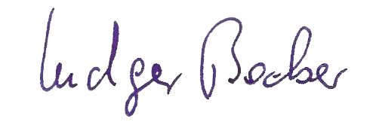
Ludger Becker
- Präsident- Carnevals-Ausschuss Wesel e.V.

